Bansilal Ramnath Agarwal Charitable Trust’s
VISHWAKARMA INSTITUTE OF TECHNOLOGY – PUNE

CS2311: Software Engineering

Division |  |  | SY CS-A
Batch |  |  | 3
GR Number (PRN) |  |  | 12413610
Roll No. |  |  | 10
Name |  |  | ABHISHEK SARAF

Assignment 4

Problem Statement
- Design detailed class and object diagrams using UML tools (e.g., StarUML, Visual Paradigm) for a given problem statement.
CLASS DIAGRAM FOR A FINANCIAL FRAUD DETECTION SYSTEM

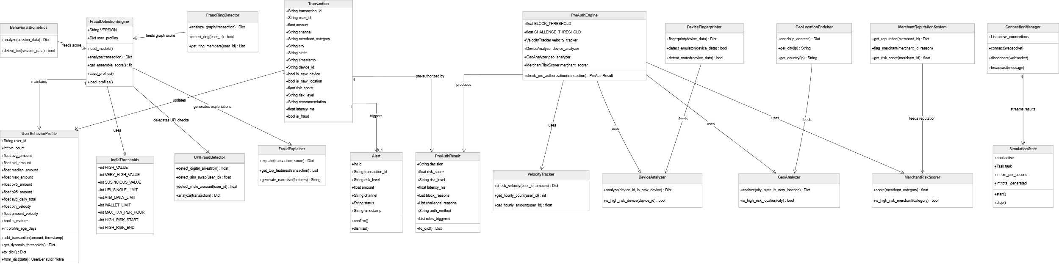

OBJECT DIAGRAM FOR A FINANCIAL FRAUD DETECTION SYSTEM

